**LAB # 02**

Q. Print numbers from 1 to 10 using a for loop.

Q. Print all even numbers between 1 and 20 using a while loop.

1. Calculate the sum of numbers from 1 to 100 using a loop.

1. Print the multiplication table of 5 using a loop.

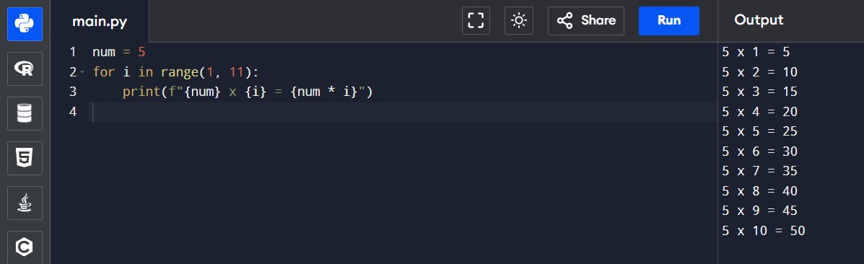

1. Find the factorial of a given number using a for loop.

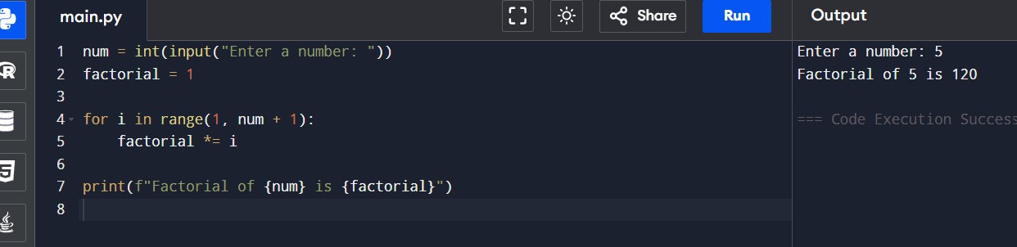

1. Iterate over a list of fruits and print each item.

1. Create a list of numbers and print only the odd numbers using a loop.

